Prediction of Singapore’s Total Live Births and Total Fertility Rate Using Time Series Models
Ebony Hunt
June 8, 2026
Abstract
Intorointor

This study forecasts predictions of the TFR and TLB based on historical data using ARIMA and SARIMA models.
Keywords: Total Fertility Rate (TFR), Total Live Births (TLB), ARIMA, SARIMA

Introduction
Globally, total birth and fertility rates have been declining since the mid 20th century. The average fertility rate has dropped from 5 in 1950 to below 2.5 children per woman in 2020, and over 80% of the world’s total population lives in countries where the average woman will give birth to less than 3 children in her lifetime (Becker et al.). This decline in birth and fertility rates is even more present in Singapore. The country has some of the lowest fertility rates globally, with the total fertility rate reaching 0.94 in 2023. This is considerably lower than the replacement rate of 2.1 for the same year (Roser et al.).
In a response to extreme population growth following a baby boom in the years following World War 2 (Swee-Hock), the Singapore National Family Planning and Population Program introduced the Two-Child Policy in 1966 to reduce the nation’s live birth rate. The aim was to reach replacement fertility by 1990 and zero population growth by 2030 by providing paid medical leave for women undergoing sterilization and restricting tax benefits for families with over three children (Seng). The result of this policy, and an increase of female labour participation rates due to cultural shifts in the country lead to fertility reaching below replacement rates by 1975 (Singh et al.).
Birth and fertility rates significantly lower than the replacement rate are a cause for concern for governments of high-income countries globally. This is due to a series of economic and social factors. Low birth rates lead to an increasingly aging average population, and population decline over time. An ageing population is detrimental to a nation’s economy as there is a smaller number of potential productive workers, and a larger number of people dependant on governmental financial support (Kravdal).
The Singapore government introduced several pronatalist policies in 1987 in an attempt to raise birth and fertility rates. These policies involved increasing tax benefits for families with over three children, increasing tax benefits for married couples, and eliminating paid medical leave for middle- and upper-class women undergoing sterilization procedures. These policies have been revised and updated in 2004, 2008, and 2013 after reviewing data from the Marriage and Parenthood Survey conducted by the National Population and Talent Division in the years prior to these reforms (Jones and Hamid).
Despite these pronatalist incentives introduced in the late 1980’s, Singapore’s birth and fertility rates continue to decline. Due to the potential problems that may arise due to a countries population continuing to age faster than new children are born, visualising and predicting the future birth and fertility rates becomes increasingly important for the government to implement policy. This report will use the statistical time series models ARIMA and SARIMA to forecast the total fertility rate, and total live birth rate from 2013-2025 using the
Literature Review

Methodology
A record of all data preparation, model fitting, model validation, and forecasting is stored in the GitHub repository https://github.com/a1926113/Time_Series_Report
Data Preparation
The fertility data used in this investigation was collected by the Singapore Department of Statistics (SDoS), and the Singapore Immigration and Checkpoints Authority (ICA) from 1960 to 2025. The data includes measures of the Total Fertility Rate (TFR) which is defined by the SDoS as
It should be noted that the data prior to 1980 for the TFR pertains to the total population, while data from 1980 onwards pertains to the resident population of Singapore's citizens and permanent residents. Additionally, the measures of Resident Live-Births from 1980-1985 are estimated (Department of Statistics Singapore).
ARIMA Models
Integrated autoregressive moving average (ARIMA) models are defined as follows:
$$ϕ\left(B\right)∇^{d}X_{t}= θ\left(B\right)Z_{t}$$
with white noise residuals. $\left\{Z_{t}\right\} \sim WN(0,σ^{2})$
Here B is the backwards shift operator that shifts an observation $Y_{t}$ back by one unit of time to $Y_{t-1}$. Hence $B^{k}Y_{t}=Y_{t-k}$. Additionally, $∇ =1-B$.

These models are denoted as ARIMA(p, d, q) where p is the autoregressive lag order, d is the integrated degree of differencing, and
SARIMA Models
Seasonally integrated autoregressive moving average (SARIMA) models
Model Selection
The Birth and Fertility data used in the report was split into two distinct categories. The training data, which included the years from 1960-2012, and the testing data which included the years from 2013-2015. All data collected from 1960-2012 in the training set was used to
To comparatively assess the models found to have white noise residuals, measures of accuracy and precision were collected in figure tables and assessed to determine the best models of each . These measures of accuracy were
Additionally,
Forecasting
Results
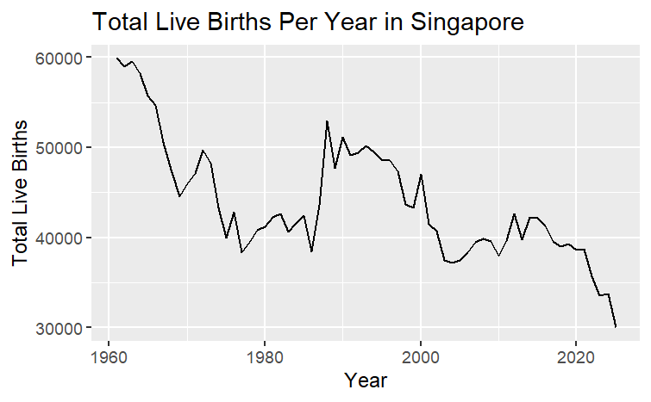
Discussion

Conclusion

References

Appendices

TFR ARIMAs | σ² | Log Likelihood | AIC | RMSE
ARIMA(13,1,15) | 0.003233 | 54.73 | -51.47 | 0.05631311
ARIMA(8,1,15) | 0.00493 | 48.25 | -48.5 | 0.06954267

TFR SARIMAs | σ² | Log Likelihood | AIC | RMSE

logTFR ARIMAs | σ² | Log Likelihood | AIC | RMSE

logTFR SARIMAs | σ² | Log Likelihood | AIC | RMSE

TLB ARIMAs | σ² | Log Likelihood | AIC | RMSE
TLB SARIMAs | σ² | Log Likelihood | AIC | RMSE

